Overview
Trigger:
Use this BPP to successfully complete the De-Enrollment from the PrePayment Program using CRM.

Business Process Procedure Overview
Background:
As part of the Smart Energy initiative release R5, CSR’s will have the ability to process PrePay de-enrollments using the Enrollment Center in CRM.

Input – Required Fields | Field Value/Comments

Output - Results | Comments
- PrePay document status updated.  - Interaction Record Created  - Bill consolidator removed  - Dunning Procedure set to standard dunning. | In the back office the PrePay document will be updated to de-enrollment completed when successful confirmation is sent from PayGo.  De-enrollment pending and de-enrollment completed interaction records will be created in CRM.  PrePay billing consolidator ‘0008’ will be removed.  The PrePay dunning procedure with update to standard dunning.

Contents

PrePay De-enrollment 3

Procedural Steps
Via Menus | (SAP Menu Path)
CRM7 | Identification / Search -> Enrollment Center -> PrePay/De-Enroll -> Submit -> De-enrollment Triggered
 | (Transaction Code can be displayed by selecting System -> Status)
 | Back Office TCode ZPPM can display the PrePay document status.

PrePay De-enrollment
The process shows how to perform a PrePay De-enrollment in CRM
Business Agree confirmed in CRM via phone call or manual searching the Business Agreement. 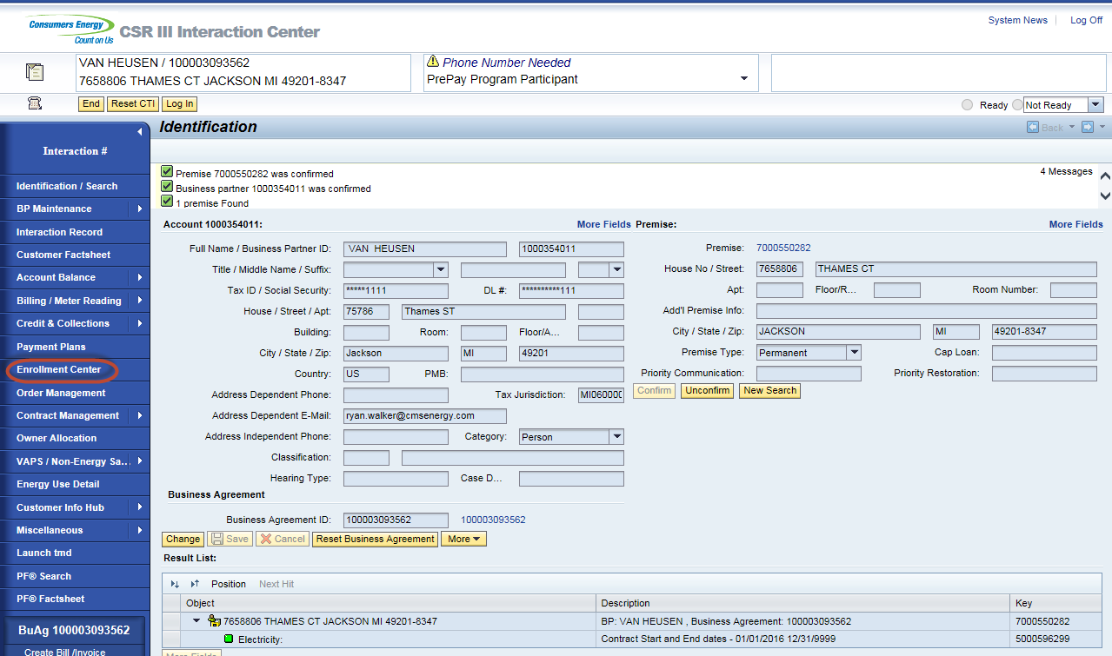
Enrollment Center displays / Click on ‘De-Enroll’
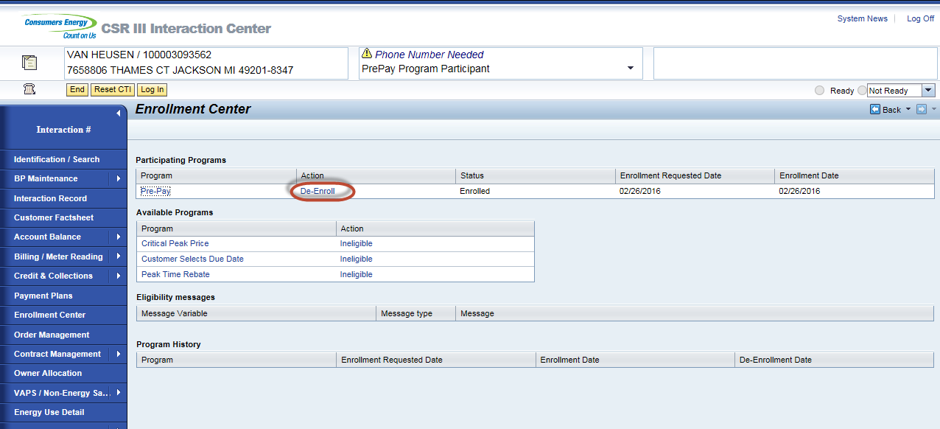
Pop-Up displays. CSR will tell the customer what their current balance will be on post pay. Business role states that if the customer wants to participate in SPP or WPP they will not be able to for 1 year. 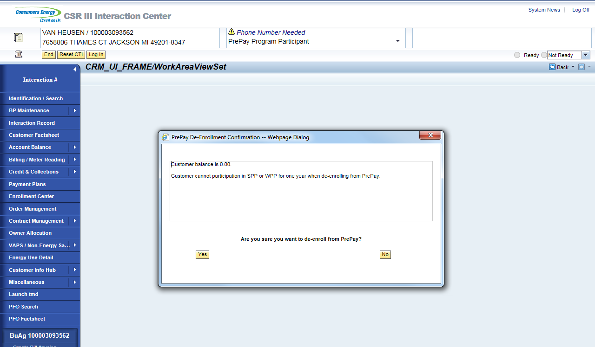
Click No or X will returns back to enrollment center
Click yes lands on Identification/ search.
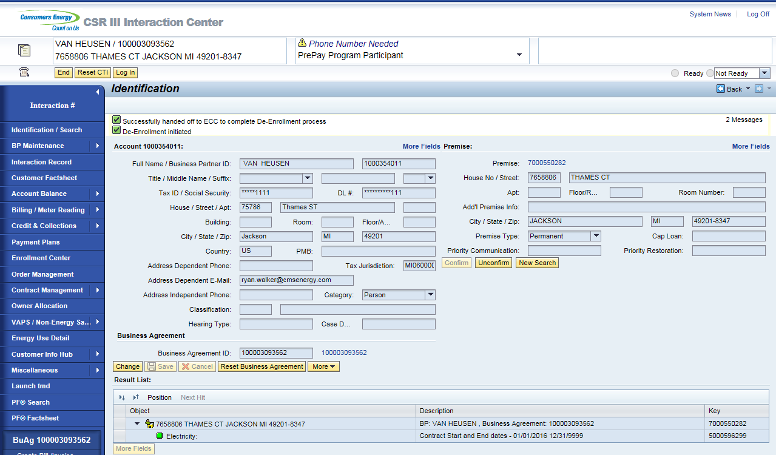

From the search screen, the CSR can select the business agreement ID number, which will land them on the Business Agreement view. The Bill consolidator ‘0008’ PrePay Account will be removed and the Dunning Procedure will be updated to CMS Standard Dunning Procedure.
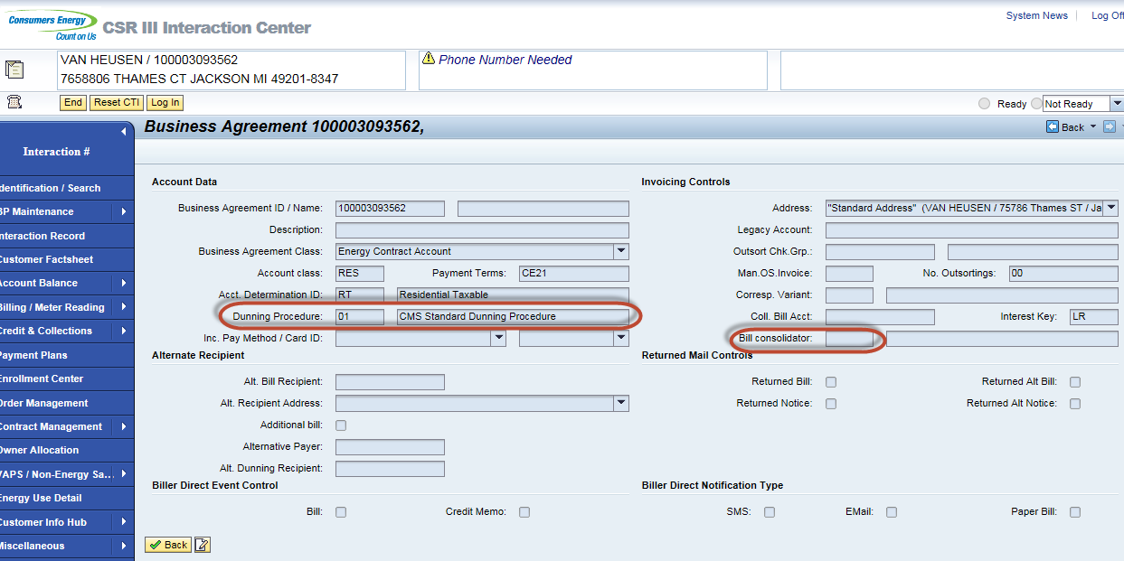
Interaction records will be created on De-enrollment
De-enrollment pending interaction record is created on PrePay de-enrollment. It shows a pending status which is waiting for the success message to come back from PayGo.
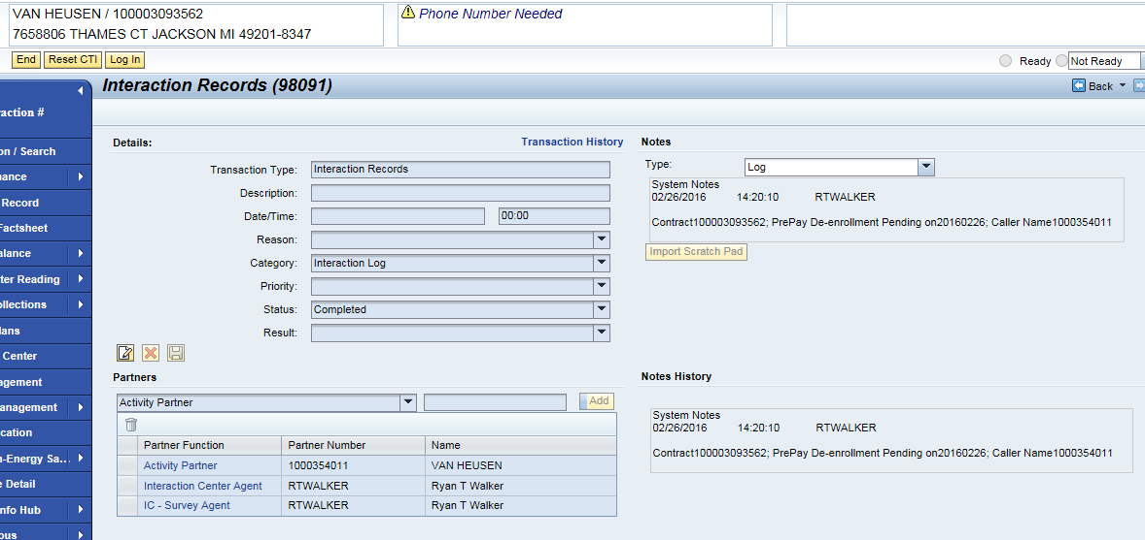
De-enrollment completed interaction record is create when SAP receives a success message from PayGo. 